**Hello Team!** **Consider the below two tables**:

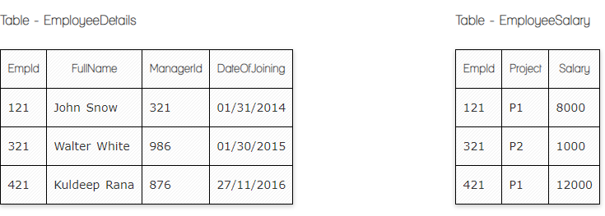

**Ques.1. Write a SQL query to fetch the count of employees working in project 'P1'.**

**Your Answer:**

**SELECT** *Project*, Count (EmpID)  
**FROM** EmployeeSalaray

**Where** Project= ‘P1’

**GROUP BY** Project;

**Ques.2. Write a SQL query to fetch employee names having salary greater than or equal to 5000 and less than or equal 10000.**

**Your Answer:**

**Select FullName**

**From EmployeeDetails**

**LEFTJOIN EmployeeSalary**

**ON EmployeeDetails.EmpId=EmployeeSalary.EmpId;**

**Select FullName**

**From EmployeeDetails**

**Where Salary Between 5000 and 10000;**

**Ques.3. Write a SQL query to fetch count of employees sorted by project's count in descending order.**

**Your Answer:**

**Ques.4. Write a query to fetch employee names and salary records. Return employee details even if the salary record is not present for the employee.**

**Your Answer:**

**Select EmployeeDETails.FullName, EmployeeSalary.Salary**

**From EmployeeSalary**

**LEFTJOIN EmployeeDetails**

**On EmployeeDetails.EmpId = EmployeeSalary.EmpId;**

**Ques.5. Write a SQL query to create an empty table with ‘Test’ name.**

**Your Answer:**

**CREATE TABLE** Test(   
**Column_name1** *NULL*,

**Column_name2**  NULL);

**Ques.6. Write a SQL query to delete an empty table with ‘Test’ name.**

**Your Answer:**

**DROP TABLE Test;**

**Ques.7. Write a SQL query to fetch all the Employees details from EmployeeDetails table who joined in Year 2016.**

**Your Answer:**

**SELECT COUNT**(EmpID), Dateofjoining  
**FROM**  EmployeeDetails  
**GROUP BY** Dateofjoining

**HAVING** COUNT(Dateofjoining) > 2016;

**Ques.8. Write a SQL query to insert new record to the EmployeeDetails table with any data.**

**Your Answer:**

**INSERT INTO** EmployeeDetails (FullName, ManagerId, Dateofjoining )  
**VALUES**  ('Ani', '3', '01/06/2024');

**Ques.9. Write a SQL query to update EmployeeSalery table with setting Salary to 2000 for Project P2.**

**Your Answer:**

**UPDATE  employeeSalary**

**SET** Salary = '2000’,   
**WHERE** Project= ‘P2’;

**Ques.10. Write a SQL query to right join both tables and draw the results.**

**Your Answer:**



**SELECT** *EmpDet.EmpId, EmpSal.Project, EmpSal.Salary*   
**FROM** *EmpSal*

**RIGHT JOIN** *EmpDet*

**ON** *EmployeeDetails.EmpID= EmployeeSalary.EmpId;*

**Now take these two tables:**

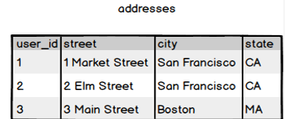

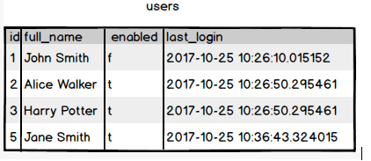

**Ques.11. Write a SQL query to fetch all users full_name from San Francisco.**

**Your Answer:**

**Ques.12. Write a SQL query to fetch all users full_name, last_login who are enabled**

**Your Answer:**

**Ques.13. Write a SQL query to fetch all users full_name who are not from Main street**

**Your Answer:**

**Ques.14. Write a SQL query to fetch all users full_name who are from Main street or San Francisco**

**Your Answer:**

**Ques.15. Write a SQL query to fetch user full_name who is equal to user_id from Boston (find user_id value in sub_query)**

**Your Answer:**